26.32: Two voltmeters with different resistances are connected in series across a 120-V line. So the current flowing is 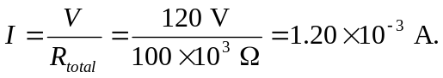 But the current required for full-scale deflection for each voltmeter is:
So the readings are:

